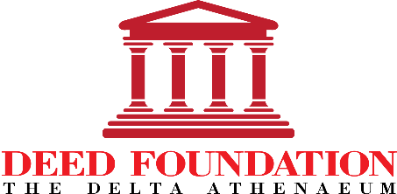 | Application  for  DEED Board Director

APPLICATIONS MUST BE SUBMITTED BY MAY 21, 2019 TO:
DEEDFOUNDATION@DEEDKCMO.ORG

The Foundation for Delta Educational and Economic Development (DEED) is a Missouri non-profit corporation focused on empowering youth, women, and families through educational and economic development. Pursuant to DEED’s Bylaws, all business affairs of the corporation are managed by the Board of Directors. Applications are currently being accepted for vacancies on the DEED Board of Directors due to term expirations for current Board members. The terms for new Board members will be effective July 1, 2019.

Members of the Board of Directors are obligated to execute their corporate responsibilities loyally and in such manner as each Director believes to be in the best interest of DEED. Each Director is also required to: (1) regularly attend the monthly DEED Board meetings on the first Monday of September - June; (2) maintain active involvement or leadership responsibility in DEED-sponsored programs and events; and (3) support the philanthropic mission of DEED with a minimum annual donation or fundraising total of $250.00.

Applicant Contact Information
Name
Street Address
City ST ZIP Code
Home Phone
Mobile Phone
E-Mail Address

Professional Background/Occupation

List most recent employment within the past 10 years
Dates of Employment | Employer and Location | Job Title

Previous Experience with DEED

Summarize your previous volunteer and leadership experience with DEED-sponsored programs, events, and activities within the past 10 years. Please provide dates of involvement.

Previous Experience with Delta Sigma Theta Sorority, Inc.

Summarize your previous volunteer and leadership experience with DST-KCMO or other local chapters of Delta Sigma Theta within the past 10 years.

Interests

Identify all areas in which you are willing to volunteer as a DEED Board Member:
Board Governance/Administration
Fundraising/Event Planning
Finance Team
Athenaeum Property Management
Athenaeum Event Coordination
Cotillion
Burning Sands Step Show
Youth Retreat
Other (describe)

Special Skills or Qualifications

Summarize special skills and qualifications you have acquired from employment, previous volunteer work, or through other activities, including hobbies or sports.

Personal Statement of Interest in the DEED Board

State the reasons you are interested in serving as a Board Director and describe any goals, plans, ideas or suggestions for enhancing the effectiveness of the DEED Board.

Agreement and Signature

By submitting this application, I affirm that the facts set forth in it are true and complete.
Name (printed)
Signature
Date

THANK YOU!

We appreciate your interest in serving on the DEED Board.

