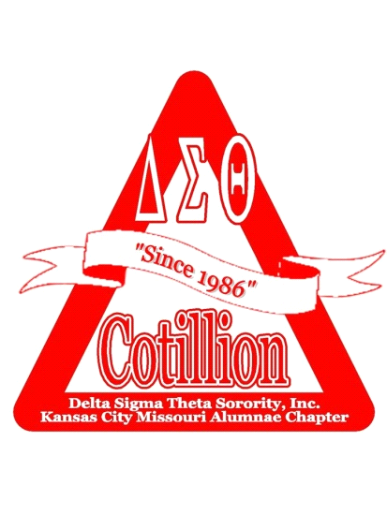 | Cotillion 2024-Program Information

Cotillion 2024 is a youth development and scholarship program sponsored by Delta Sigma Theta Sorority, Incorporated, Kansas City Missouri Alumnae Chapter and The Foundation for Delta Educational and Economic Development (DEED). Since 1986, over 970 male and female high school seniors have participated in Cotillion activities focused on college preparation, community service, personal development, and cultural enrichment. Highlights of the 2024 program will include college preparation assistance, a social justice project, mentoring relationships, a talent showcase, and scholarship awards.

All participants who successfully complete the Cotillion program will receive a minimum scholarship award of $900.00. Additional scholarships will also be awarded. Assistance with identifying external scholarship opportunities based on individual interests and abilities will also be provided.

Applications for Cotillion 2024 are available at http://deedkcmo.org/cotillion. To apply for the program, high school seniors must submit a complete application packet including the following:

- Official high school transcript reflecting a minimum cumulative grade point average of 2.5
- Two signed typewritten letters of recommendation (at least one from a teacher or academic official)
- A headshot photograph
- Fee of $225.00 for male and $250.00 for female applicants (due with the application)

The application packets can be submitted electronically or by mail, as per the instructions on the application. All application packets must be delivered or postmarked by September 10, 2023.

A Cotillion 2024 informational meeting will be held on Sunday, August 27, 2023, from 3:00 – 5:00 p.m. and Wednesday, August 30, 2023 from 6:30-8:00pm via Zoom. You must register via the link on the website to receive a Zoom invite. High school seniors are encouraged to attend with at least one parent or guardian. For questions or additional information, please contact us by email at cotillion@deedkcmo.org.

*The fee will be refunded to any applicant not approved for acceptance into the Cotillion program.

Sponsored by
Delta Sigma Theta Sorority, Inc., Kansas City Missouri Alumnae Chapter and
The Foundation for Delta Educational and Economic Development (DEED)

